LAB ACTION PLAN FOR WEEK 3
Objective:
- To work on collaborative coding by:
- Creating Organization

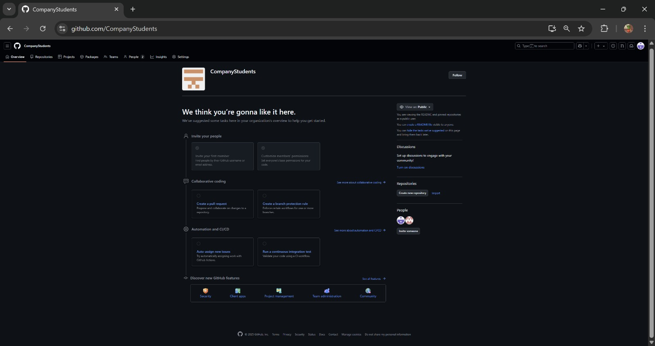

- Coordinating with others through a shared repository

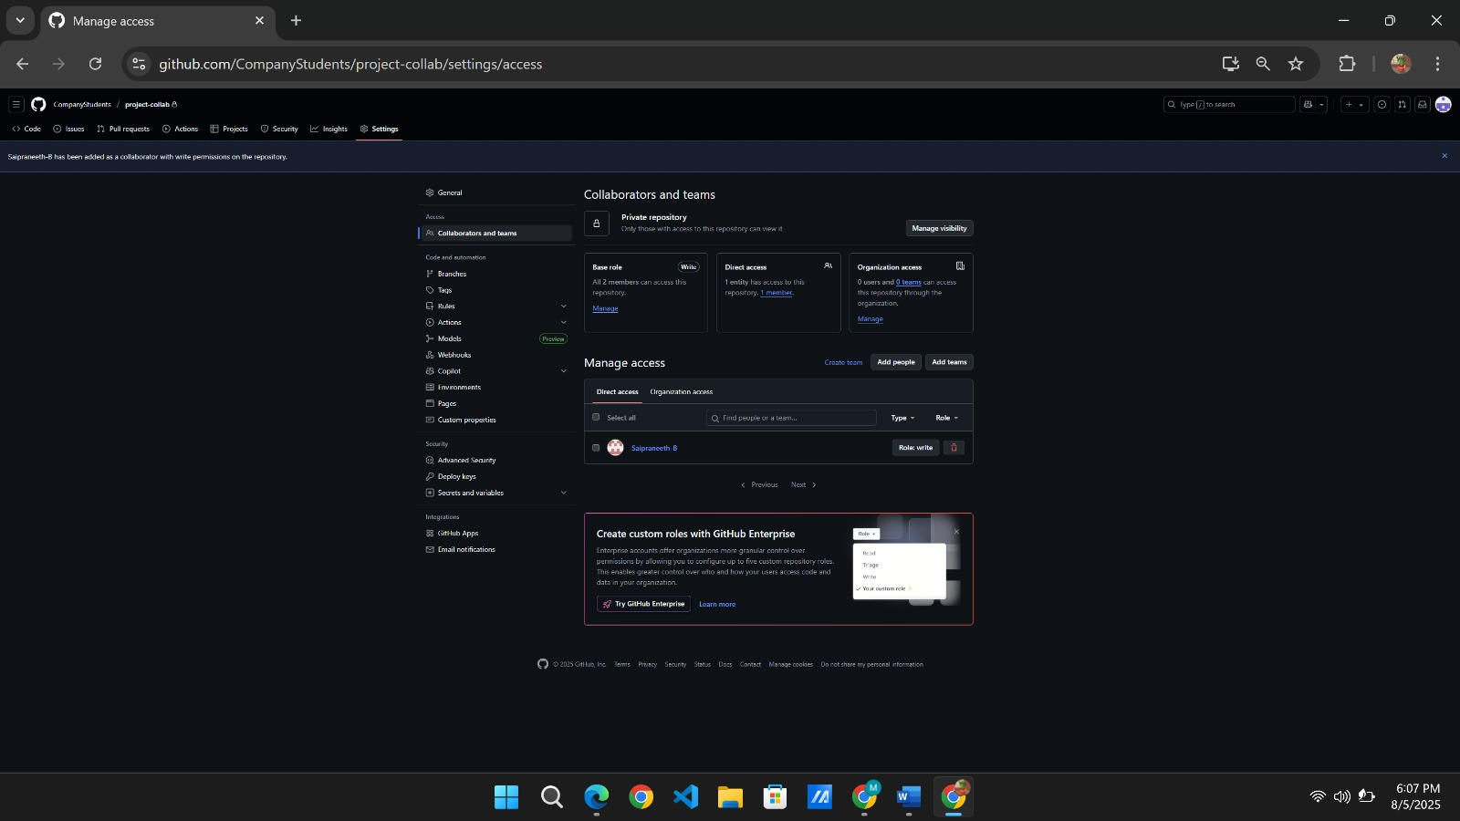

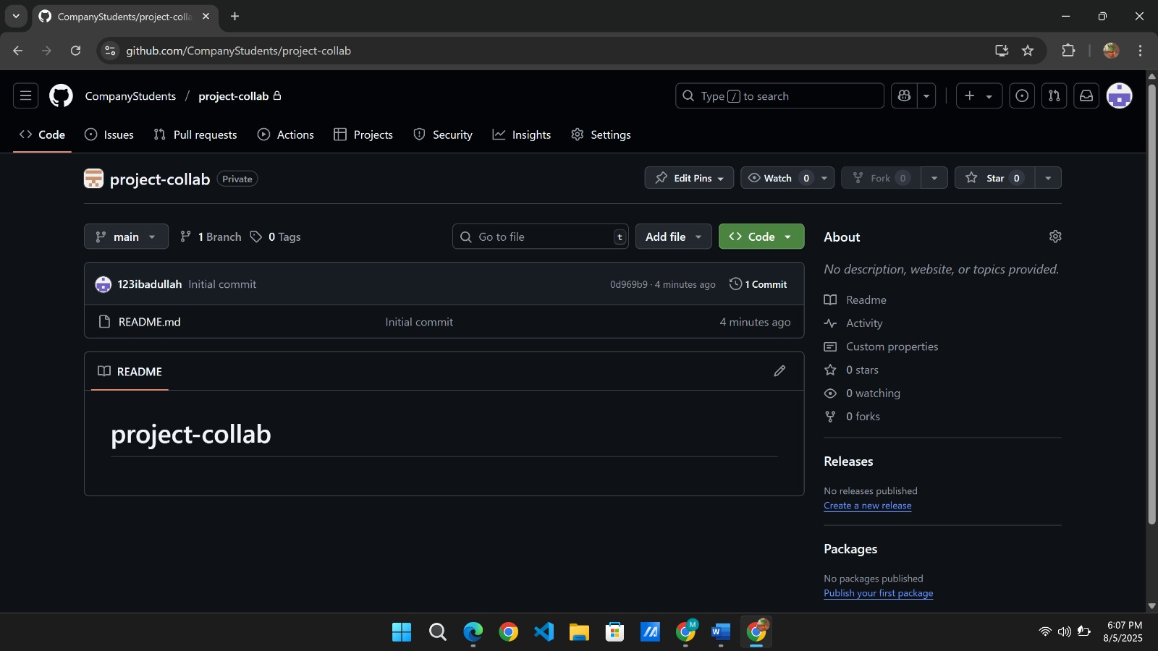
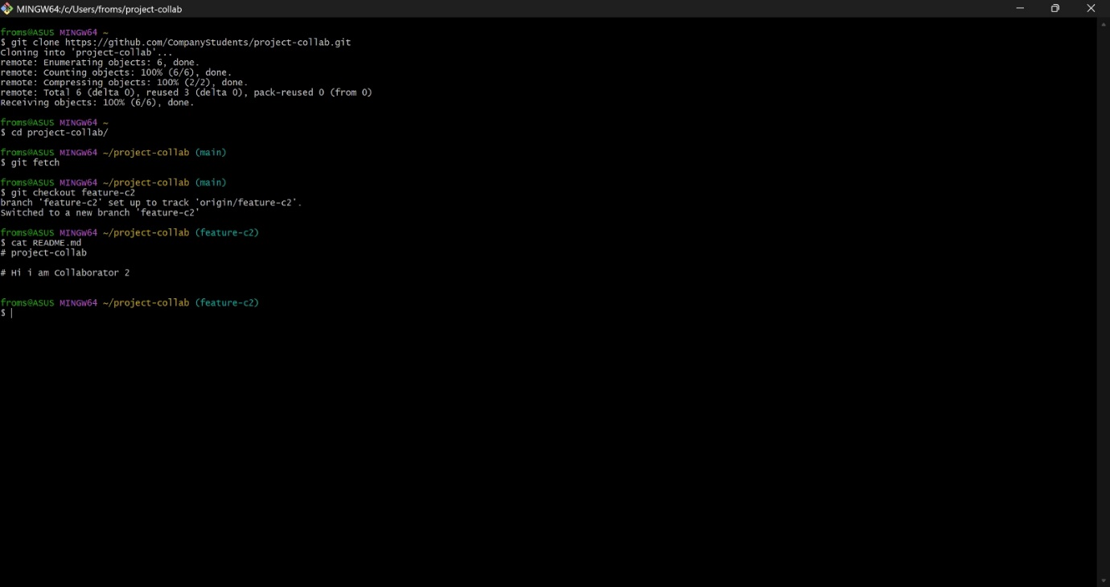

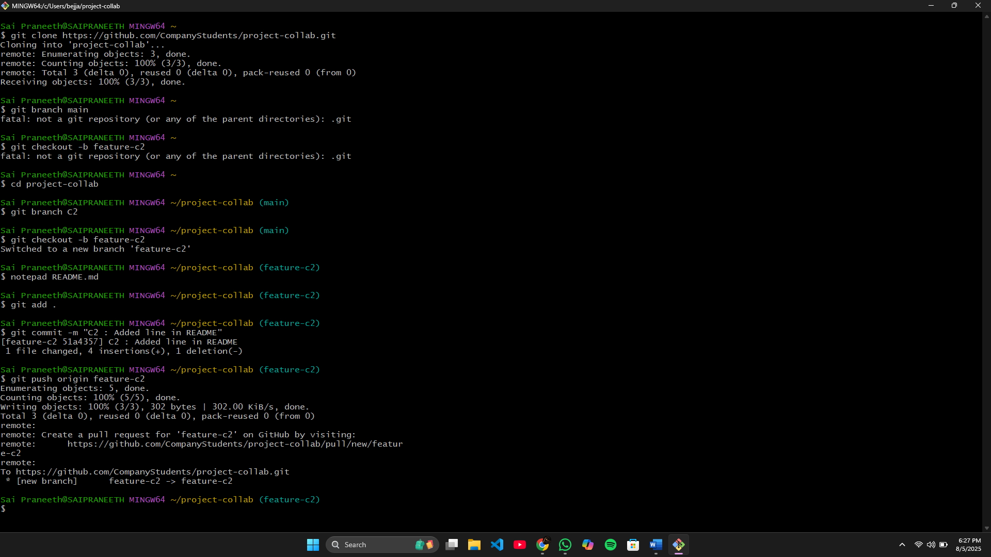

- To resolve conflicts when collaborating on same part of code.

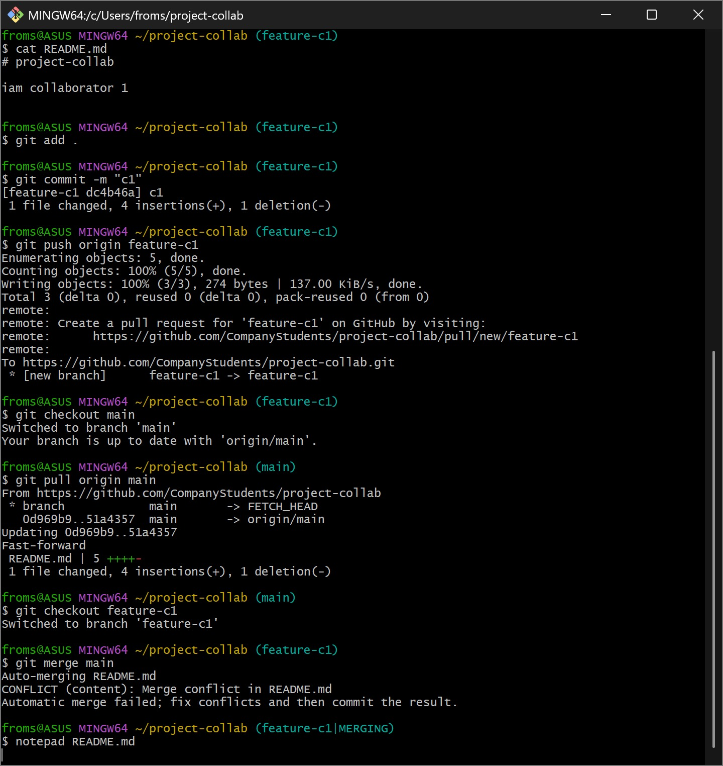

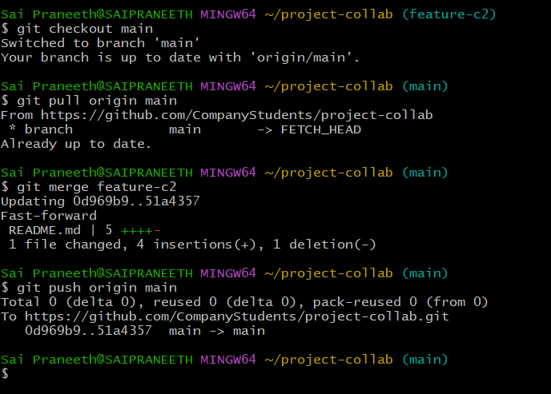

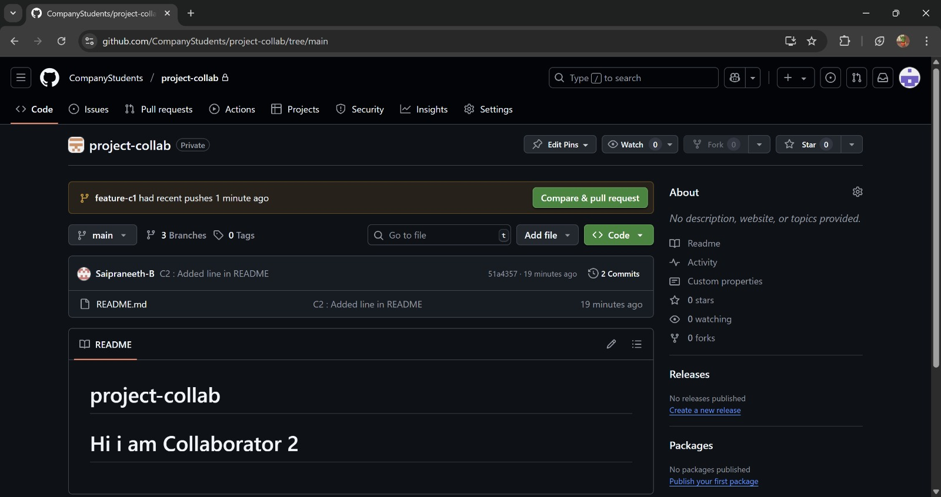

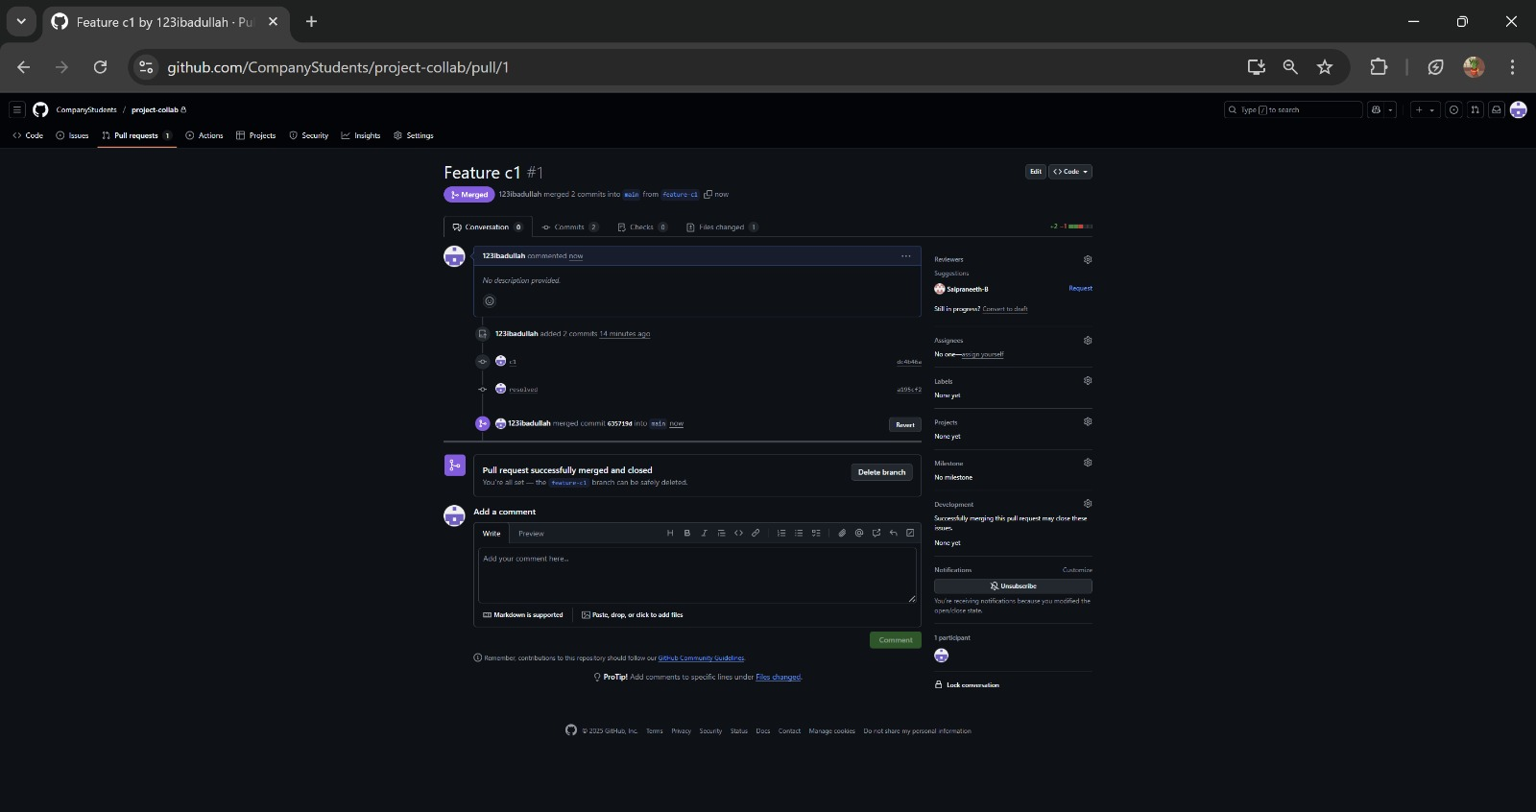

- To create and apply patch

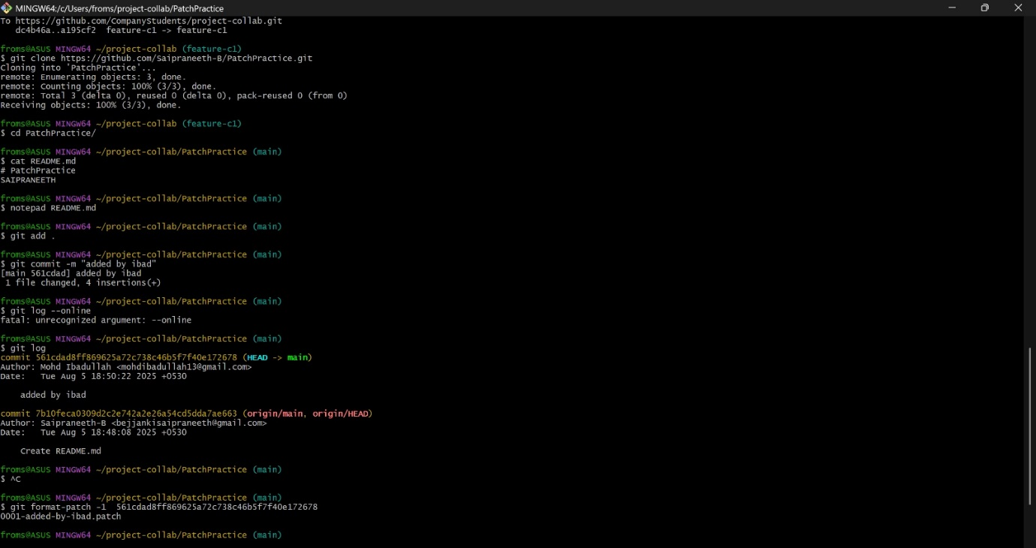

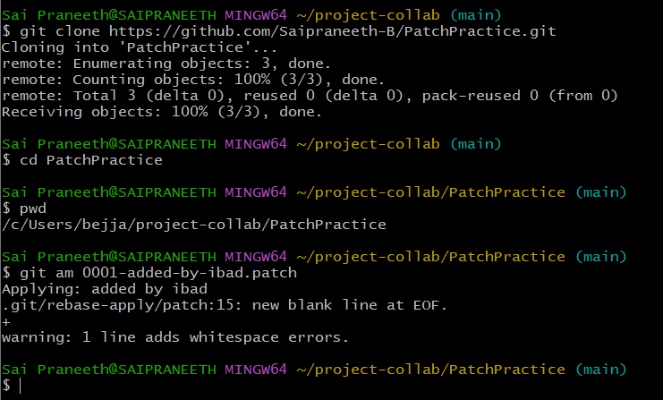

Exercise on Fork

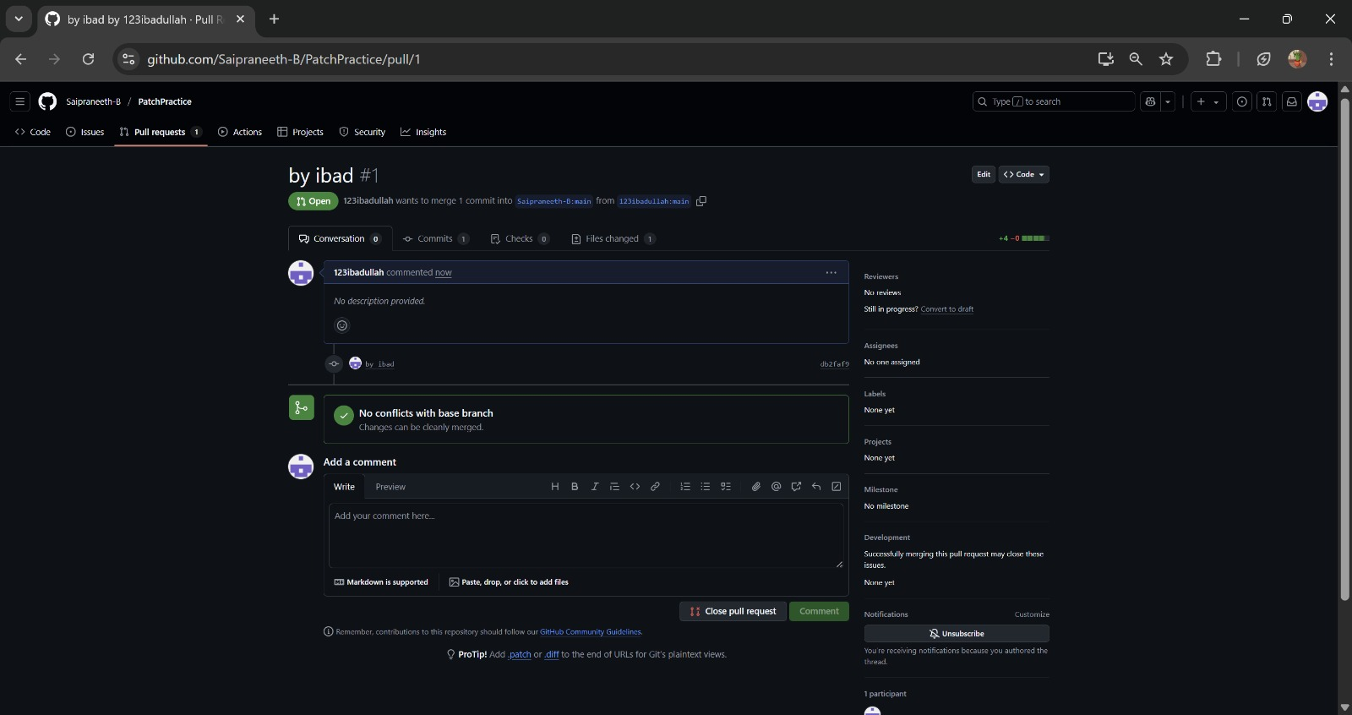

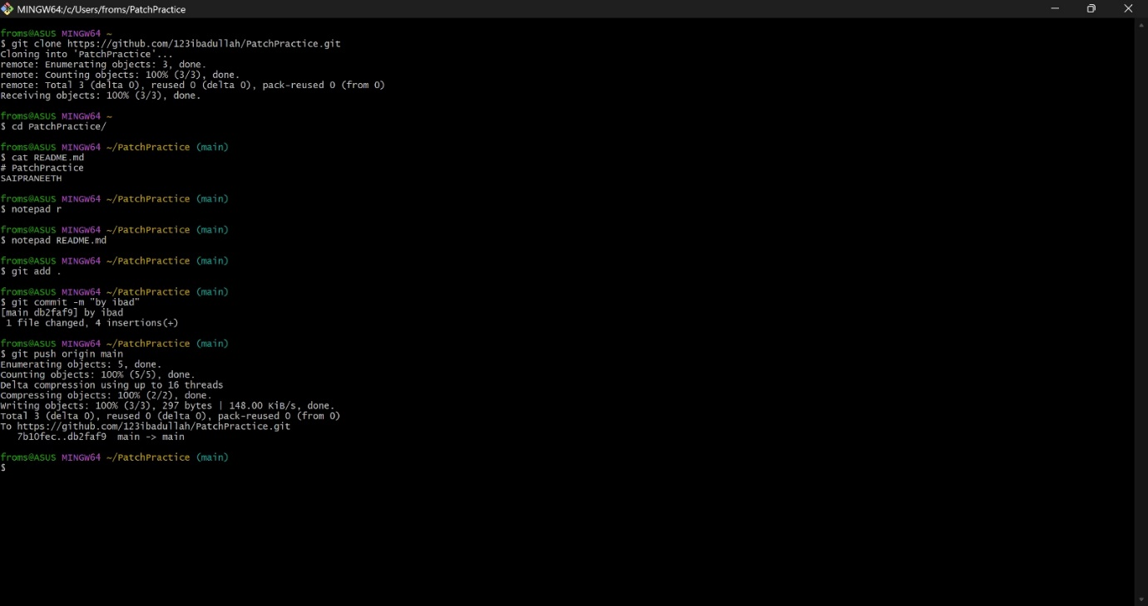

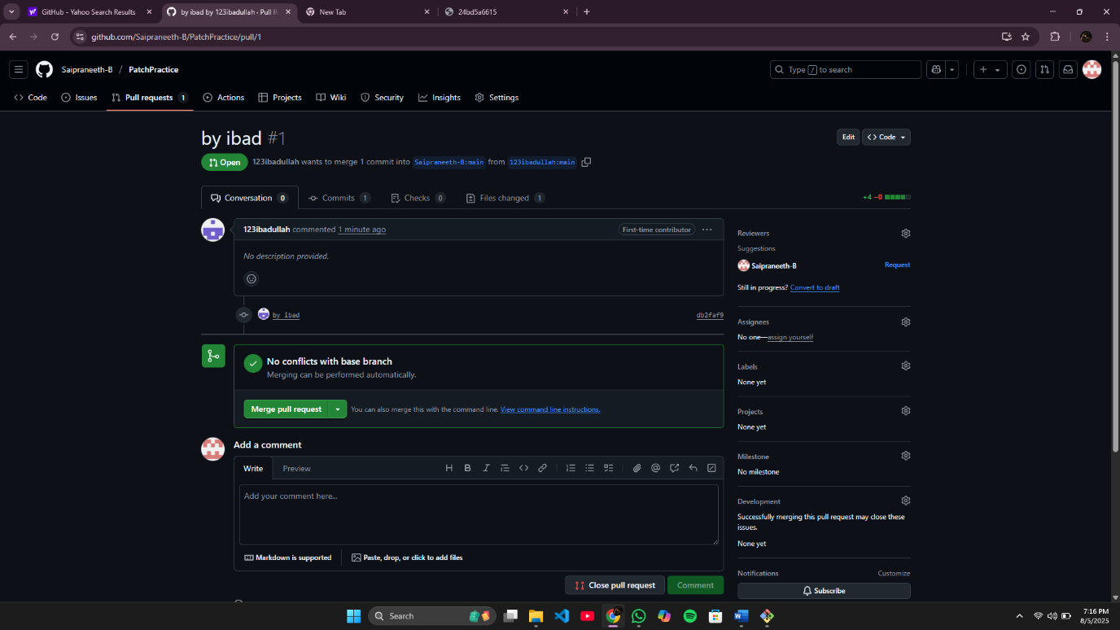

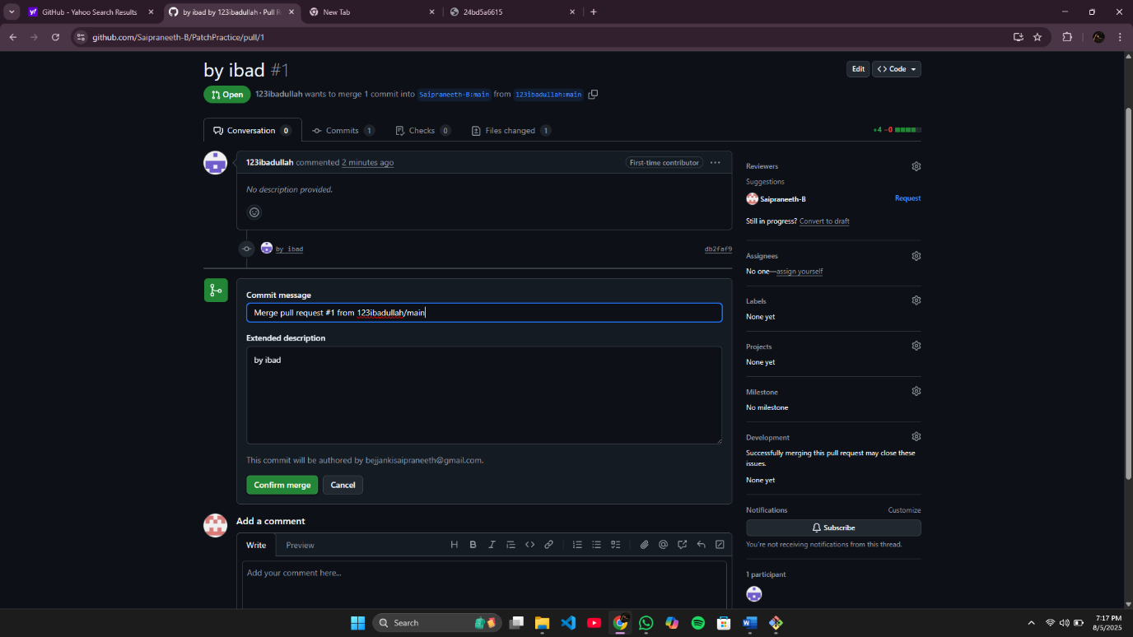

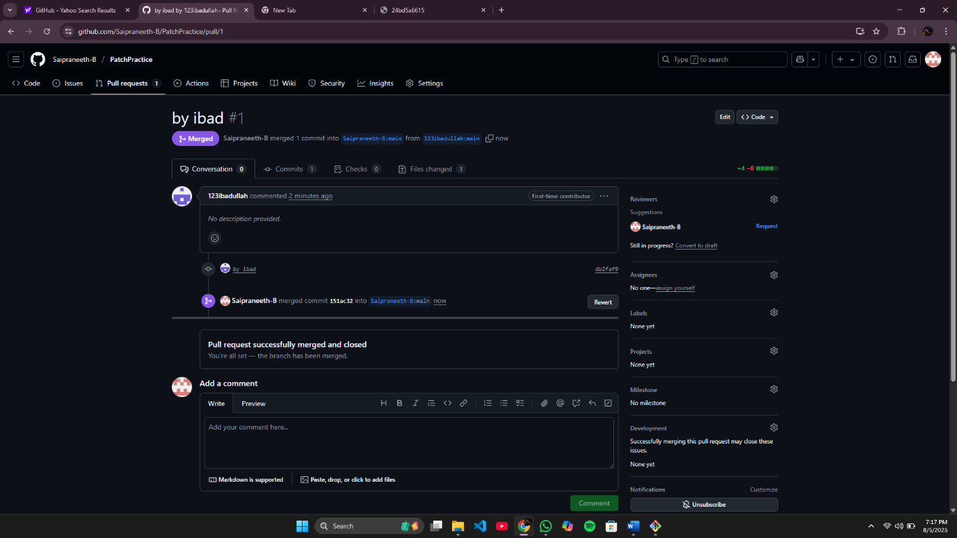

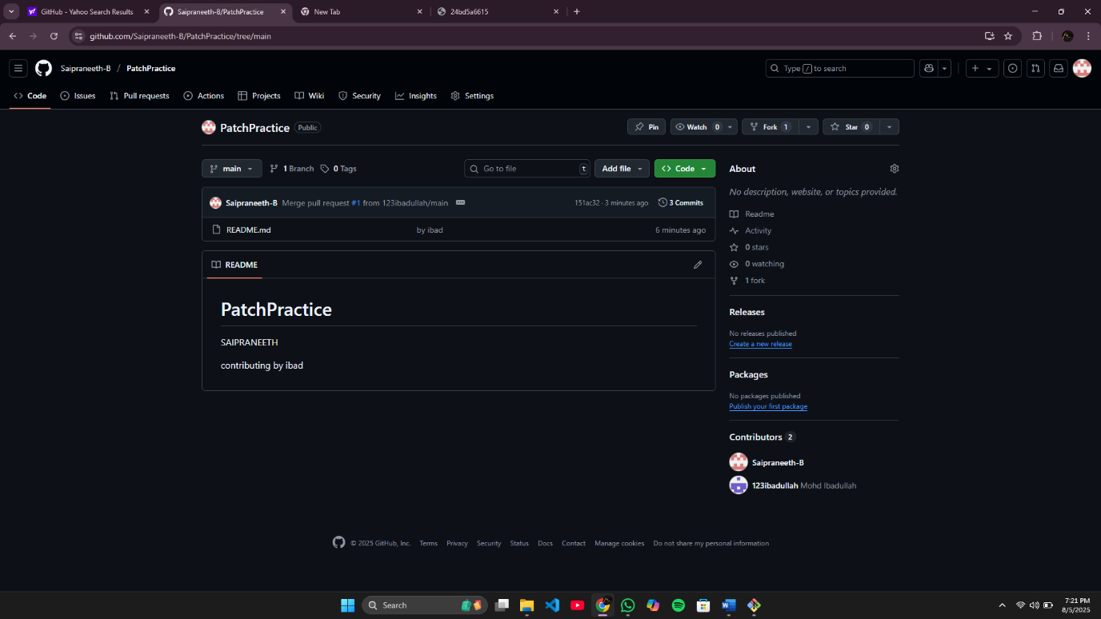

4. Scenario based questions on working with remote repository
1. You've cloned a repository and made some changes to a local branch. Now you want to push these changes to the remote repository, but you're getting an error saying "rejected - non-fast-forward." How would you resolve this?
2. You’ve been working on a feature branch, and now you need to push it to the remote repository. However, the remote repository already has a main branch. How do you push your feature branch without affecting the main branch?
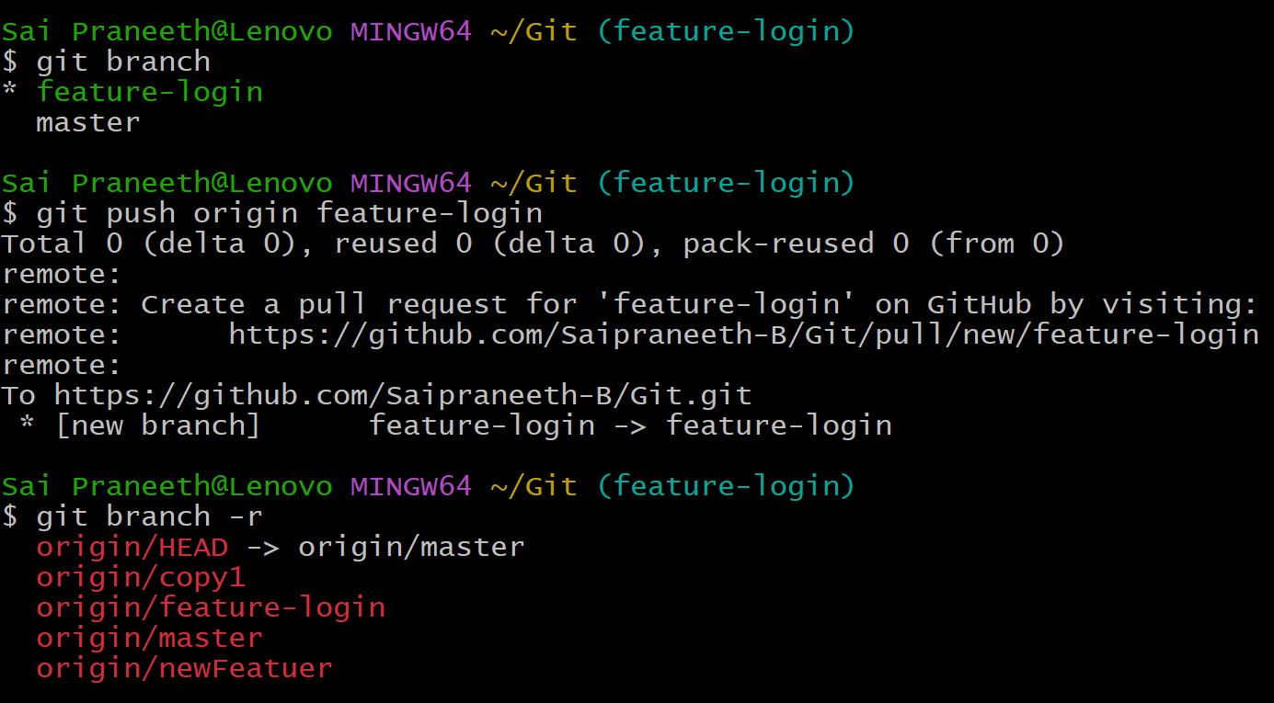
3. You cloned a remote repository, but after a while, the repository’s structure changed and new branches were added. How would you keep your local repository updated with the latest changes from the remote repository?
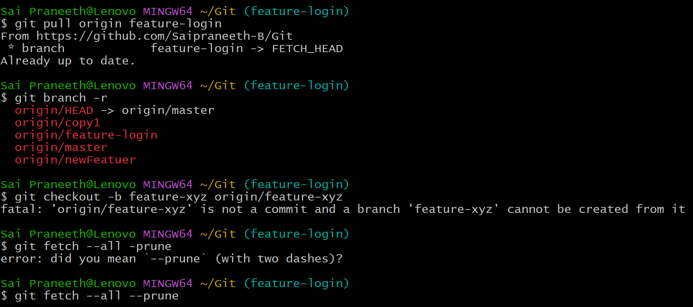

4. A colleague has pushed some changes to the main branch, but you have local changes in the same branch. You want to pull their changes, but you want to avoid merge conflicts. What steps would you take?
5. You accidentally pushed a sensitive file (e.g., API keys) to the remote repository. How would you fix this situation?
6. You’re working on a feature branch, and your manager requests that you integrate the latest changes from main into your feature branch. What steps would you take?
7. You cloned a remote repository, but later you find that you need to push your changes to a different remote repository. How do you configure your local repository to push to this new remote?
8. After running git pull, you notice that your local branch is behind the remote branch. How would you proceed to bring your local branch up to date without losing your local changes?
9. You’re working on a project with multiple collaborators, and you notice that your local changes conflict with changes that have been pushed by others. How would you resolve the conflicts?
10. You’ve pushed a feature branch to a remote repository, but now you need to delete the branch from the remote. How would you do that?
Scenario:
You are working on a collaborative project hosted on GitHub with a team of four developers. The main branch is main, and each developer works on their own feature branches.
You are assigned to implement a new UI component in a branch called feature/ui-update. Meanwhile, another team member has made a critical bug fix and pushed it directly to the main branch. When you try to push your changes, your push fails due to upstream changes.
Additionally, a teammate has submitted a patch file with a small CSS fix and shared it via email. You need to apply the patch, test it, and merge everything into main without breaking any functionality.
11. What command will you use to bring your local main branch up to date with the remote repository before merging it into your feature branch?
12. How will you update your feature/ui-update branch to reflect the latest changes from main?
13. Which command should you use to attempt pushing your local feature branch again, and what should you do if it fails due to conflicts?
14. How do you apply a .patch file provided by your teammate and include it in your commit history?
15. After successful testing, describe the steps (with commands) to merge your feature branch into main and push it to GitHub.

